State of California
California Natural Resources Agency
Department of Water Resources
South Central Region Office

San Joaquin River Restoration Program
Bank Erosion Monitoring Report
(2024 Update)

July 2024

DRAFT
Table of Contents
1.0 Introduction 1
2.0 Background 2
3.0 Methods 3
3.1 Hydrograph Data 4
4.0 Results 5
4.1 Previous High Threat Sites Update (2024) 6
4.2 Lower San Joaquin Levee District Flood Threat Sites 18
5.0 Conclusion and Recommendations 21
6.0 References 23

List of Figures
Figure 1 San Joaquin River Study Area by Reach and High Threat Site Locations Identified by DWR in 2021 2
Figure 2 San Joaquin River Hydrograph of Mean Daily Discharge at SJF (RM 266.0) and SDP (RM 181.2) Stream Gages 4
Figure 3 San Joaquin River Reach 1, RM 262.2; Threat Ratio 1.15, Threat Level: High 10
Figure 4 San Joaquin River Reach 1, RM 258.5; Threat Ratio 0.0, Threat Level: High 11
Figure 5 San Joaquin River Reach 2A, RM 222.5; Threat Ratio 0.29, Threat Level: High 12
Figure 6 San Joaquin River Reach 2A, RM 220.6; Threat Ratio 0.67, Threat Level: High 13
Figure 7 San Joaquin River Reach 3, RM 202.6; Threat Ratio 1.1, Threat Level: High 14
Figure 8 San Joaquin River Reach 3, RM 200.3; Threat Ratio 0.0, Threat Level: High 15
Figure 9 San Joaquin River Reach 3, RM 194.4, Threat Ratio 1.38, Threat Level: High 16
Figure 10 San Joaquin River Reach 5, RM 131.3; Threat Ratio 0.0, Threat Level: High 17

List of Tables
Table 1 Flow Releases 5
Table 2 Erosion at Previously Identified High Threat Sites 6
Table 3 Threat Classifications for Levee District Sites 18

Acronyms and Abbreviations
CALOES California Governor's Office of Emergency Services
CCC California Conservation Corps
cfs Cubic feet per second
DWR California Department of Water Resources
EOS Office of Emergency Services
FOC Flood Operations Center
LSJLD Lower San Joaquin Levee District
PEIS/R Program environmental impact statement/report
Restoration Area San Joaquin River between Friant Dam and the Merced River confluence
RM River mile
SDP San Joaquin River Gage near Dos Palos
SJF San Joaquin River Gage below Friant
SJRRP San Joaquin River Restoration Program

Introduction
The San Joaquin River Restoration Program (SJRRP or Program) was established to meet two goals; one of which is to restore a self-sustaining, naturally reproducing salmon fishery back to the San Joaquin River (SJR). Restoration Flows now maintain a connected river channel from Friant Dam to the confluence with the Merced River except during critically dry water years. The SJRRP, in collaboration with federal and state agencies, developed a Program Environmental Impact Statement/Report (PEIS/R) to identify and minimize the impacts of the Program, including the need to “monitor erosion and perform maintenance and/or reduce Interim and Restoration Flows as necessary to avoid erosion-related impacts” (San Joaquin River Restoration Program 2012). The California Department of Water Resources (DWR) took lead in identifying and monitoring bank erosion within the Restoration Area (Figure 1) and completed a bank erosion monitoring report in 2021. This erosion monitoring can help better inform the Program and other entities on potential erosion resulting from Restoration Flows.
The 2021 report served as an initial step in identifying and monitoring critical erosion sites. It developed a baseline for future evaluations and recommended monitoring highest threat sites to determine potential causes and changes in erosion patterns related to Restoration Flows. This report provides an update to the 2021 report and evaluates eight high-threat erosion sites that were identified in the previous report. This update uses aerial imagery before and after flood management releases in 2019 and 2023 to relate erosion extents to the different flow types released from Friant Dam. In addition to the sites previously identified by DWR, this report also includes a cursory review of flood-threat sites identified in 2023 by the Lower San Joaquin Levee District (LSJLD) as another entity observing erosion for flood control purposes.
Figure 1 San Joaquin River Study Area by Reach and High Threat Site Locations Identified by DWR in 2021
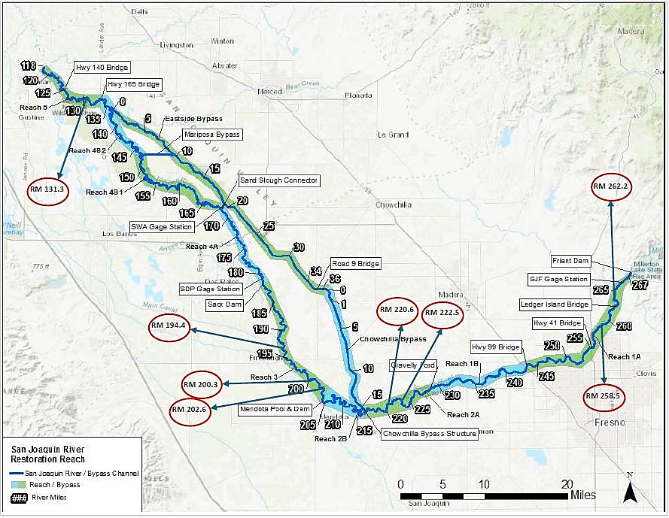

Background
Flows released from Friant Dam are categorized as three primary flow types. These include Restoration Flows, contract deliveries, and flood management releases. During a wet year type, Restoration Flows may be already accounted for in flood management releases consistent with the Settlement. The magnitude and duration of each flow-type has the potential to cause erosion based on the geotechnical conditions of the riverbank and applied hydraulic force. To simplify identifying and monitoring erosion sites, DWR used aerial imagery to track erosion throughout the Restoration Area and compared flow releases to help determine when erosion occurred. With this approach, DWR performed a comprehensive evaluation of bank erosion along the SJR and flood bypass system in 2021 that was built upon the foundation of the 2010 Tetra Tech study, and the 2016 DWR pilot study. The 2021 report identified vulnerable areas where monitoring for erosion should be continued to ensure the protection of nearby infrastructure and property to support the assessment of the potential effects of Restoration Flows.
In the 2021 report, DWR reviewed 268 locations for the presence of erosion utilizing aerial imagery from 2015 to 2017. Fifty locations showed signs of bank erosion after 2017 flood management releases. High-, medium-, and low-threat classifications were assigned to each site based on their proximity to infrastructure. Eight sites were classified as high-threat, and twenty-two sites were classified as medium-threat. The cause of erosion related to flow-type was uncertain because all flow types were present between the aerial imagery dates that were used. However, DWR assumed that the erosion shown in the 2021 report was most likely a response to flood management releases occurring between January and July 2017; and was less likely caused by Restoration Flows because daily averages were small in comparison (California Department of Water Resources 2021).
DWR has committed to continue monitoring erosion in these areas to ensure that the SJRRP actions avoid significant erosion-related impacts. This commitment involves a long-term erosion monitoring plan that continues to evolve as data-gaps are assessed and remote sensing technology improves over time. Periodic reports will provide an evaluation of erosional areas recommended for monitoring from the last report update and provide new recommendations, if any. This report follows a recommendation from the 2021 report to monitor high-threat sites and improve the understanding of how Restoration Flows, contract deliveries, and flood management releases affect erosion sites in the Restoration Area.

Methods
The following describes delineation methods, site nomenclature, and threat classifications used for this report. Aerial imagery from various sources were used to track changes in erosion extents over time. Imagery dates were selected based on changes in flow releases from Friant Dam, primarily between Restoration Flows and flood management releases. This was done to compare changes in erosion patterns and relative extents between these flow types. This report focuses on the high-threat sites from the 2021 report, and includes additional areas identified by the LSJLD where erosion was apparent on aerial imagery.
Aerial Imagery Bank Delineations: In general, this method of delineation is the process of outlining the top of the riverbank or the edge of the water on aerial photos. After the delineation is completed, they are compared to determine if there were any changes over time. These changes could suggest bank erosion or deposition. Based upon imagery available for each site, either high-resolution aerial photos from 2022 or Google Earth imagery from 2018 to 2024 were used for delineation. Delineations are limited by overhanging vegetation, shadows, flow inundation, and pixel resolution. These limitations made it difficult to identify the exact bankline to determine how much erosion occurred at some sites. However, for the purpose of this monitoring it is sufficient for determining whether significant erosion did occur.
River Mile and Levee Mile Stationing: This report refers to the location of the sites using River Miles (RMs) and levee miles. RMs start at zero in the Sacramento-San Joaquin Delta and end 267 miles upstream just below Friant Dam. The levee miles for the Eastside Bypass start at the downstream end of the bypass at the confluence of the San Joaquin River and count upstream from zero to 36.
Threat Classification: The risk of erosion to structures (which is defined as human-made additions within the study area), was determined by calculating a threat ratio as described in the 2021 report. This ratio is the distance to the nearest structure divided by the distance of lateral erosion measured between the photoset dates. A smaller threat-ratio value means a more significant threat from erosion at that site. Sites with threat ratios lower than 3.0 were determined as critical and designated as a high threat. Sites that showed erosion but had a threat ratio between 3 and 10 were designated as a medium threat. The sites that showed no perceptible erosion from 2015 were designated as a low threat.

Hydrograph Data
Flow types play a crucial role in understanding the relative flow magnitudes between the photoset dates. DWR identified three key flow categories: Restoration Flows, contract deliveries, and flood management releases. The information for each flow category was collected from the California Data Exchange Center (CDEC) and the SJRRP (www.restoreSJR.net).
The hydrograph data used for this analysis is a continuation of the one created for the 2021 report and adds flow releases through April 2024 as shown in Figure 2. The vertical gray lines show when flow types changed with the flow types labeled at the top of the chart. Imagery dates are also identified at the bottom of the chart.
Figure 2 San Joaquin River Hydrograph of Mean Daily Discharge at SJF (RM 266.0) and SDP (RM 181.2) Stream Gages
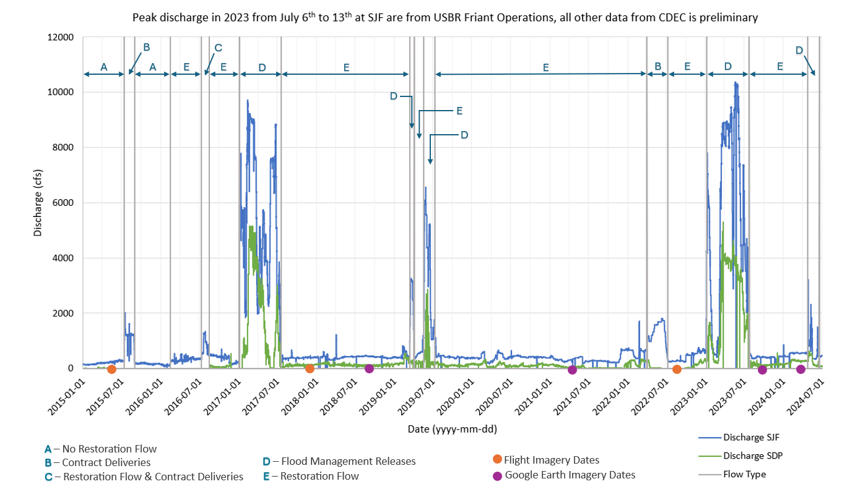
Since the last update in 2021, flood management releases occurred in 2019, spanning from March 15th to April 5th, May 19th to July 11th, and again in 2023 from January 8th to February 5th and from March 8th to July 26th. Restoration Flows covered most of the remaining duration through 2024 except for a 3-month period in 2022 when Restoration Flows were reduced for contract deliveries and for temperature management of the reservoir. Specific flow types, the number of days released, and their start and end date since 2017 are summarized in Table 1.
Table 1 Flow Releases
Start Date | End Date | Days | Flow Type
8/1/2017 | 3/15/2019 | 591 | Restoration
3/15/2019 | 4/5/2019 | 21 | Flood management release
4/5/2019 | 5/19/2019 | 44 | Restoration
5/19/2019 | 7/11/2019 | 53 | Flood management release
7/11/2019 | 4/1/2022 | 995 | Restoration
4/1/2022 | 7/8/2022 | 98 | Contract deliveries
7/8/2022 | 1/5/2023 | 181 | Restoration
1/5/2023 | 2/6/2023 | 32 | Flood management release
2/6/2023 | 3/8/2023 | 30 | Restoration
3/8/2023 | 7/27/2023 | 141 | Flood management release
7/27/2023 | 5/1/2024 | 280 | Restoration
Following the 2017 flood management releases, additional flood management releases were made for 247 days, contract deliveries for 98 days, and Restoration Flows for 2,121 days. While these flow characteristics provide insight into relative erosion, they alone do not determine erosion causes definitively. Further data and analyses are necessary to identify the exact factors contributing to erosion during this period.

Results
This report builds upon the 2017 findings as well as includes additional sites identified as possible areas of concern by the LSJLD as the agency that manages the flood control system. To evaluate previously identified high threat sites, DWR used aerial imagery from April 2015, December 2017, August 2018, April 2021, September 2022, October 2023, and February 2024. Comparison of the newer imagery with past delineations identified those sites with erosion following significant flow events. The magnitude of erosion varied between sites. The results, detailed in Table 2, provide an update on erosion at the previously identified high threat sites. The table also shows the maximum distance of lateral erosion and the minimum distance to the nearest infrastructure over time. This includes delineations for the post-2017 flood management releases from the previous report and new delineations before and after flood management releases in 2019 and 2023. The distances shown in Table 2 are not always measured at the same location. The minimum and maximum distances varied year by year based on site-specific erosion trends and location.
Table 2 Erosion at Previously Identified High Threat Sites
River Mile | 2015 - 2017 |  | 2017 - 2018 |  | 2018 - 2021/2022 |  | 2021/2022 - 2023/2024
River Mile | Maximum Lateral Erosion (feet) | Minimum Distance to Structure (feet) | Maximum Lateral Erosion (feet) | Minimum Distance to Structure (feet) | Maximum Lateral Erosion (feet) | Minimum Distance to Structure (feet) | Maximum Lateral Erosion (feet) | Minimum Distance to Structure (feet)
262.20 | 55 | 85 | 10 | 82 | 17 | 81 | 21 | 68
258.50 | 10 | 0 | 1 | 0 | 12 | 0 | 15 | 0
222.50 | 140 | 45 | 0 | 45 | 72 | 40 | 10 | 40
220.60 | 37 | 75 | 8 | 71 | 19 | 60 | ND¹ | ND¹
202.60 | 20 | 33 | 5 | 33 | 4 | 33 | 10 | 33
200.30 | 55 | 3 | 2 | 3 | 8 | 3 | 21 | 3
194.4 | 12 | 24 | ND¹ | ND¹ | 4 | 16 | 9 | 16
131.30 | 11 | 0 | ND¹ | ND¹ | 9 | 0 | 18 | 0
¹ Not Determined
Significant flow events appear to influence erosion patterns observed in aerial imagery. The duration between the 2017 and 2018 imageries experienced only Restoration Flows, resulting in relatively lower erosion extents in a few areas compared to erosion observed after flood management releases. Imagery was not available for all sites around the 2021/2022 timeframe; therefore, some sites used 2021 imagery to assess pre-2023 flood management releases and other sites used imagery from 2022. Between the 2018 and 2021 imageries, Restoration Flows continued, but had a 74-day break for flood management releases in 2019, which peaked up to 6,500 cubic feet per second (cfs). For those sites that used imagery in 2022, it includes the continuation of Restoration Flows and 98 days of contract deliveries from April to July 2022.
Post-2023 flood management releases were assessed using available imagery either from 2023 or 2024. Significant flood management releases over a period of 173 days occurred between January and July 2023, with peak flows up to 10,000 cfs. The erosion observed in this period is likely related to these significant flood management releases. Site-specific changes at each high-threat site identified in the 2021 report are further described in the following section.

Previous High Threat Sites Update (2024)

RM 262.20
The site is located in Reach 1A at the southern end of Ledger Island and features an unprotected riverbank that was identified in a previous report as a high-threat area due to its proximity to a gravel mining pit separated by an eroding bank (Figure 3). From 2015 to 2017, a maximum lateral erosion of 55 feet was observed, reducing the minimum distance to the structure to 85 feet. Most of the erosion during this period occurred around the middle of the eroding bank and was likely due to flood management releases in 2017. In August 2018, using Google Earth imagery, the maximum lateral erosion between 2017 and 2018 was measured at 10 feet at a different location, and the minimum distance to the structure slightly reduced to 82 feet. Most of the erosion during this period shifted to the upstream end of the site in an area away from the minimum distance to the gravel pit. By April 2021, Google Earth imagery showed additional erosion at the upstream area up to 17 feet, with the minimum distance to the structure further reduced to 81 feet. The latest imagery from October 2023 showed additional erosion throughout the entire extent of the eroding bank up to 21 feet from 2021, with the minimum distance to the structure reduced to 68 feet.
Most of the erosion continued towards the upstream end of the site and relatively less erosion downstream where it is closer to the gravel pit. The erosion trends observed at this site appear to be influenced by the different flow types over the years. Between 2017 and 2018, additional erosion was relatively less as a result of Restoration Flows and appeared to occur only at the upstream area of the site. This erosion trend continued through 2021 as Restoration Flows continued along with 74 days of flood control releases with peak flows up to 6,500 cfs in 2019. Based on these observations, most of the additional erosion up to 2023 that impacts the minimum distance to the structure is assumed to occur because of the 2023 flood management releases where substantial flood control flows were released for 173 days, with peak flows up to 10,000 cfs. Following this flood event, erosion was observed throughout the entire extent leading to an erosion pattern similar to what was observed after the 2017 flood. Monitoring at this site showed distinct differences in erosion trends based on flow type, where erosion from Restoration Flows is relatively less and focused only on the upstream half of the site compared to the magnitude and extent of erosion after a significant flood event.

RM 258.50
This site is located near Owl Hollow within Reach 1A and features an unprotected riverbank with an embankment dirt road as the nearest threatened structure, separating a gravel mining pit from the river (Figure 4). In 2017, the maximum lateral erosion was 10 feet and began to erode into the dirt road. In August 2018, significant erosion was not observed with continuous Restoration Flows, but by April 2021, erosion increased an additional 12 feet at the downstream end following Restoration Flows and 74 days of flood control releases in 2019. Additional erosion between this timeframe was likely caused by flood management releases based on trends observed at this site during Restoration Flows between 2017 and 2018. Additional erosion of up to 15 feet was observed after the 2023 flood. Erosion trends at this site appear to be largely influenced by flood management releases where most of the changes were observed; minor erosion was observed during Restoration Flows.

RM 222.50
This site is located within Reach 2A and is a threat to a levee with farm buildings and an orchard beyond it (Figure 5). Between 2015 and 2017, the maximum lateral erosion was 140 feet, with the minimum distance to the levee at 45 feet, primarily around the middle section. In August 2018, no significant erosion was observed. In September 2022, an additional 72 feet of erosion was observed, particularly at the upstream area and the minimum distance to the structure reduced to 40 feet. By October 2023, an additional 10 feet of erosion was observed; however, the minimum distance to the levee did not change because erosion occurred at the upstream end further away from the levee. This site was protected by the LSJLD during the 2023 flood where rock slope protection was placed along the eroding bank. The erosion trends at this site appear to be influenced by varying flow types; Restoration Flows between 2017 and 2018 caused minimal erosion, while flood management releases from 2019 and 2023 had a considerable impact on erosion patterns.

RM 220.60
This site is located within Reach 2A, with the nearest threatened structure being a levee and row crops beyond it (Figure 6). Between 2015 and 2017, the maximum lateral erosion was recorded at 37 feet with the most significant erosion observed around the middle of the site; and the minimum distance to the levee was equal to 75 feet. In August 2018, Google Earth imagery showed additional erosion up to 8 feet, but the minimum distance to the structure remained unchanged at 75 feet. Erosion occurred only at a few locations, but a majority of the site remained unchanged during this period. By September 2022, additional erosion up to 19 feet was observed throughout the site, reducing the minimum distance to the levee to 60 feet. During this period, uniform erosion along the entire bankline was observed. The 2019 flood control releases are believed to have contributed to new erosion observed up to 2022. Erosion after the 2023 flood was not delineated because the bankline was not clear in the imagery. In general, this site shows a uniform erosion trend along the bankline after major flood releases and relatively less erosion during periods of Restoration Flows.

RM 202.60
This site is located within Reach 3 and features a sparsely vegetated riverbank without any bank protection (Figure 7). The nearest threatened structure is a service road along a canal. From 2015 to 2017, the site experienced a maximum lateral erosion of 20 feet, reducing the minimum distance to the structure to 33 feet. Most of the erosion occurred at the downstream end. In August 2018, additional erosion up to 5 feet was observed, but occurred away from the minimum distance to the service road, leaving that distance unchanged. By 2022, an additional 4 feet of erosion was observed again at the downstream end and not impacting the minimum distance to the road. Following the 2023 flood, an additional 10 feet of erosion was observed at the downstream end. These changes can be attributed to varied flow types where erosion appears to be expanding downstream more after a flood event compared to Restoration Flows.

RM 200.30
This site is in Reach 3 and depicts vegetation loss and no bank protection (Figure 8). As identified in the previous report, the nearest structure threatened is a service road and row crops just south of the site. The 2017 bankline delineation for this site is uncertain in some areas because of overhanging vegetation and shadows caused by them. Due to this reason the 2017 delineation crosses over the delineations for 2018 and 2022 banklines.
From 2015 to 2017, the site experienced a maximum lateral erosion of 55 feet, with a minimum distance to the structure at 3 feet. By August 2018, additional erosion was observed up to 2 feet at the downstream end, not impacting the minimum distance to the structure. By 2022, additional erosion up to 8 feet continued at the downstream end. The latest imagery from February 2024 shows additional erosion up to 21 feet throughout the site following the 2023 flood. Erosion observed between 2022 and 2024 is likely caused by the 2023 flood. For this site, the effect of Restoration Flows between 2017 and 2018 is not clear due to uncertainties of the 2017 bankline delineation, but considerable erosion was observed between 2018 and 2024 along the upstream and downstream ends, which is likely due to flood management releases.

RM 194.40
This site is in Reach 3 within the city of Firebaugh and depicts light vegetation with riprap serving as bank protection (Figure 9). The nearest threatened structure is a residential neighborhood. Bankline delineations for this site are uncertain because of vegetation growth, image resolution, and flow inundation. Based on these delineations, it may be assumed that there is up to 20 feet of erosion between 2015 and 2024; however, changes are not apparent and because of the riprap, there should be minor changes. Additional data collection and site visits will need to be conducted to further assess changes in erosion and impacts to nearby infrastructure.

RM 131.30
This site is located in Reach 5 and features a 430-foot-long barren bank that is actively eroding and encroaching within the side slope of a levee. Between 2015 and 2017, the site experienced up to 11 feet of erosion, which continued to increase an additional 9 feet by 2022; and by February 2024, the upstream area eroded an additional 18 feet. Google Earth imagery for 2024 does not cover the full extent of this site and further evaluation will be needed to identify the extent of erosion downstream. Most of the additional erosion observed in 2022 and 2024 are likely caused by flood management releases in 2019 and 2023. After communicating with the LSJLD, this site may no longer be classified as a high-threat site because the area is within the Great Valley Grasslands State Park where they have begun breaching the levee to flood native ground and restore floodplain habitat.
Figure 3 San Joaquin River Reach 1, RM 262.2; Threat Ratio 1.15, Threat Level: High
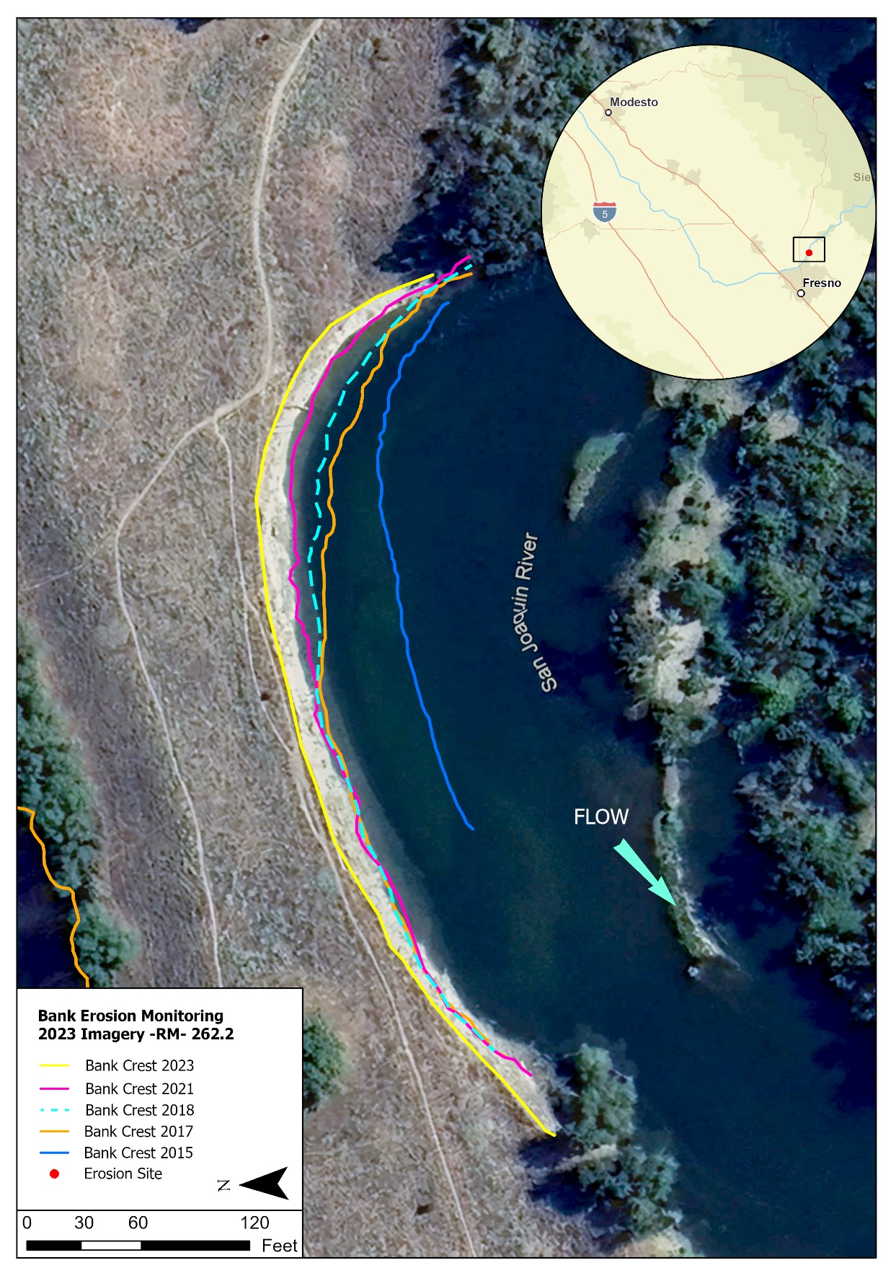
Figure 4 San Joaquin River Reach 1, RM 258.5; Threat Ratio 0.0, Threat Level: High
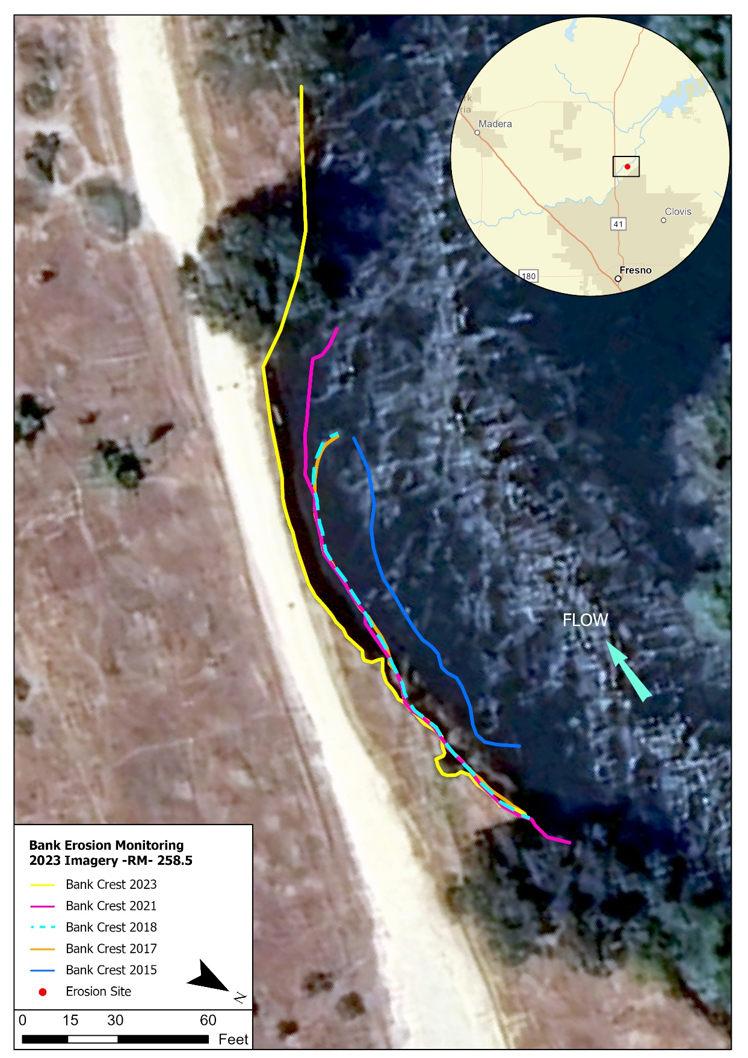
Figure 5 San Joaquin River Reach 2A, RM 222.5; Threat Ratio 0.29, Threat Level: High
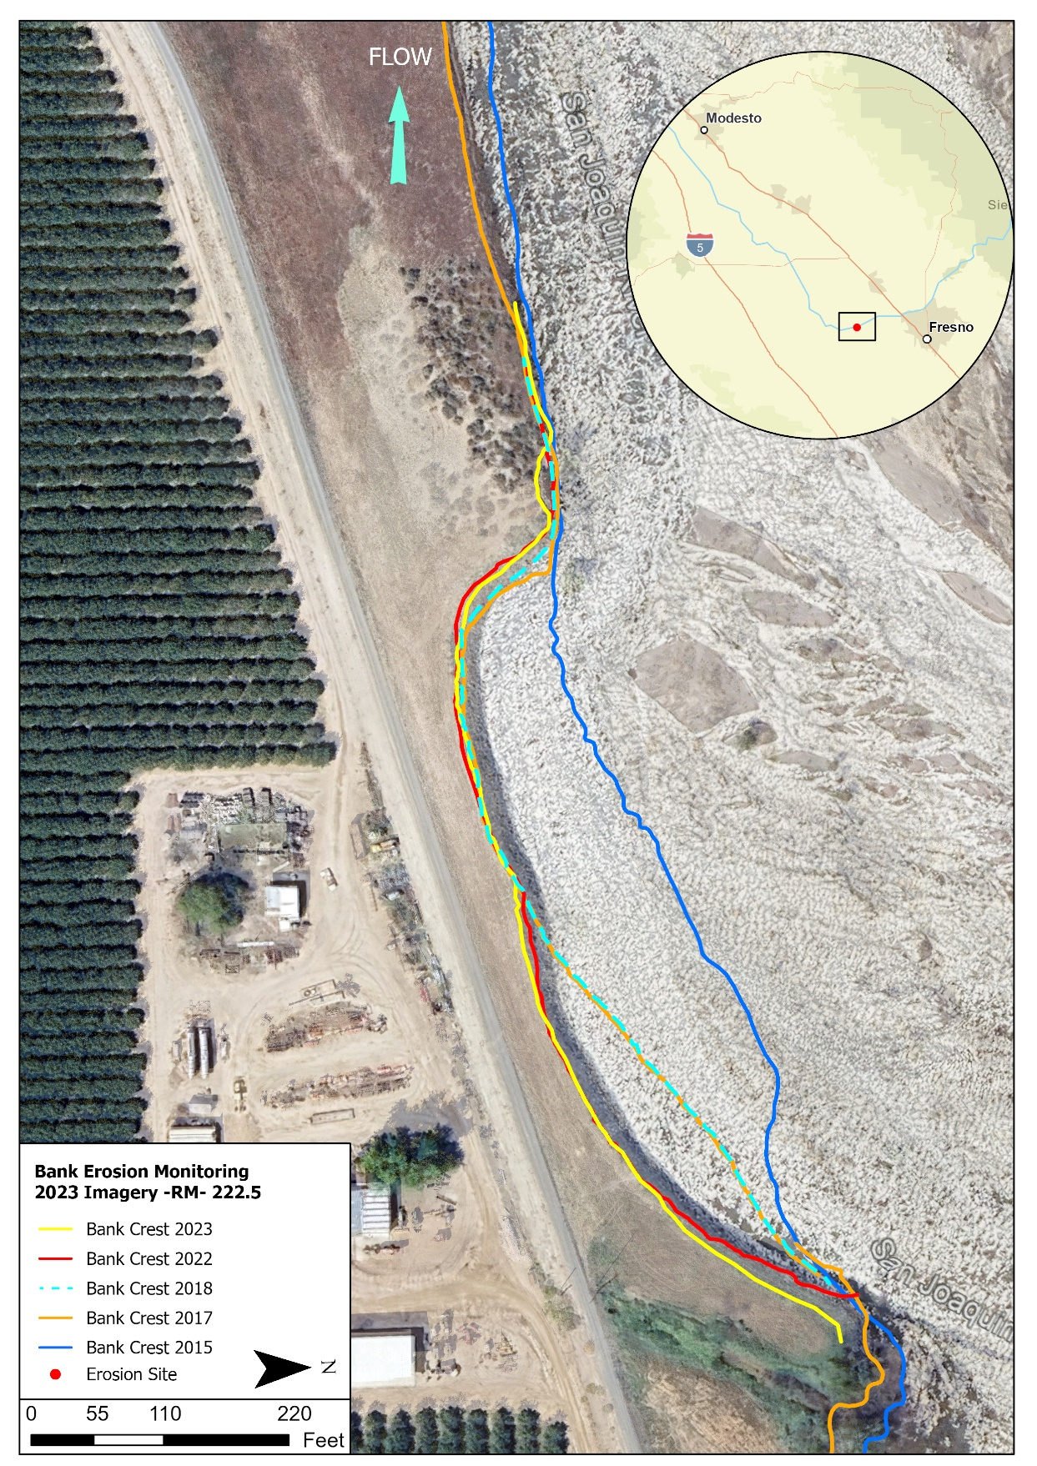

Figure 6 San Joaquin River Reach 2A, RM 220.6; Threat Ratio 0.67, Threat Level: High
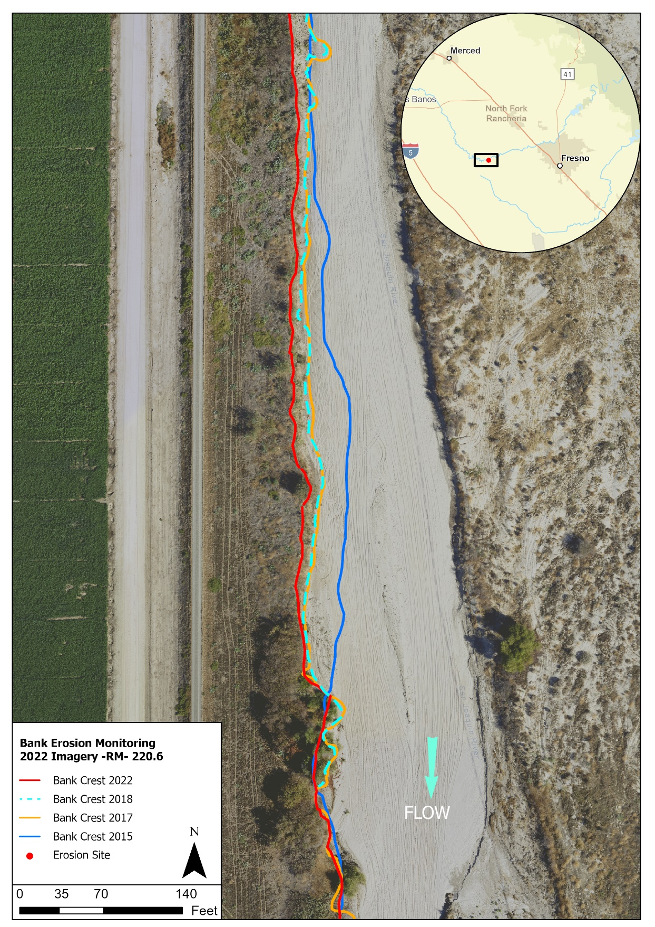

Figure 7 San Joaquin River Reach 3, RM 202.6; Threat Ratio 1.1, Threat Level: High
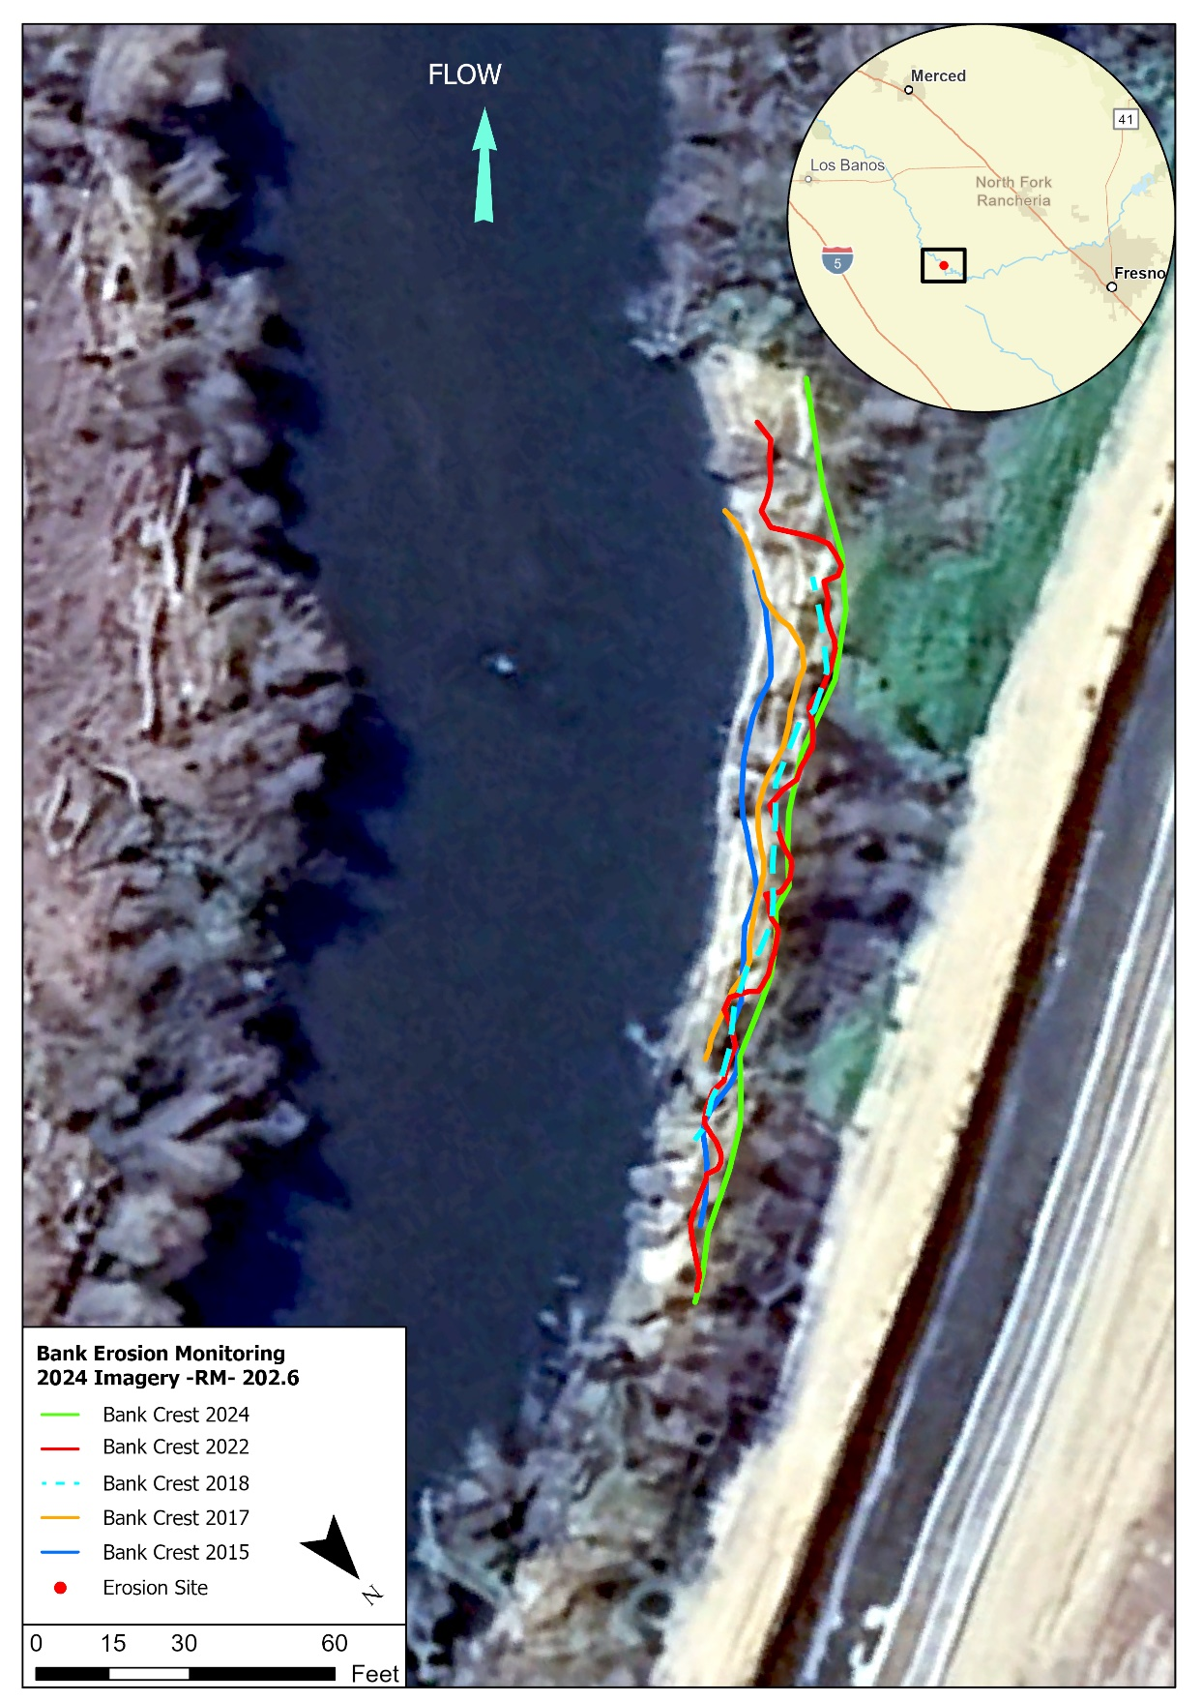

Figure 8 San Joaquin River Reach 3, RM 200.3; Threat Ratio 0.0, Threat Level: High
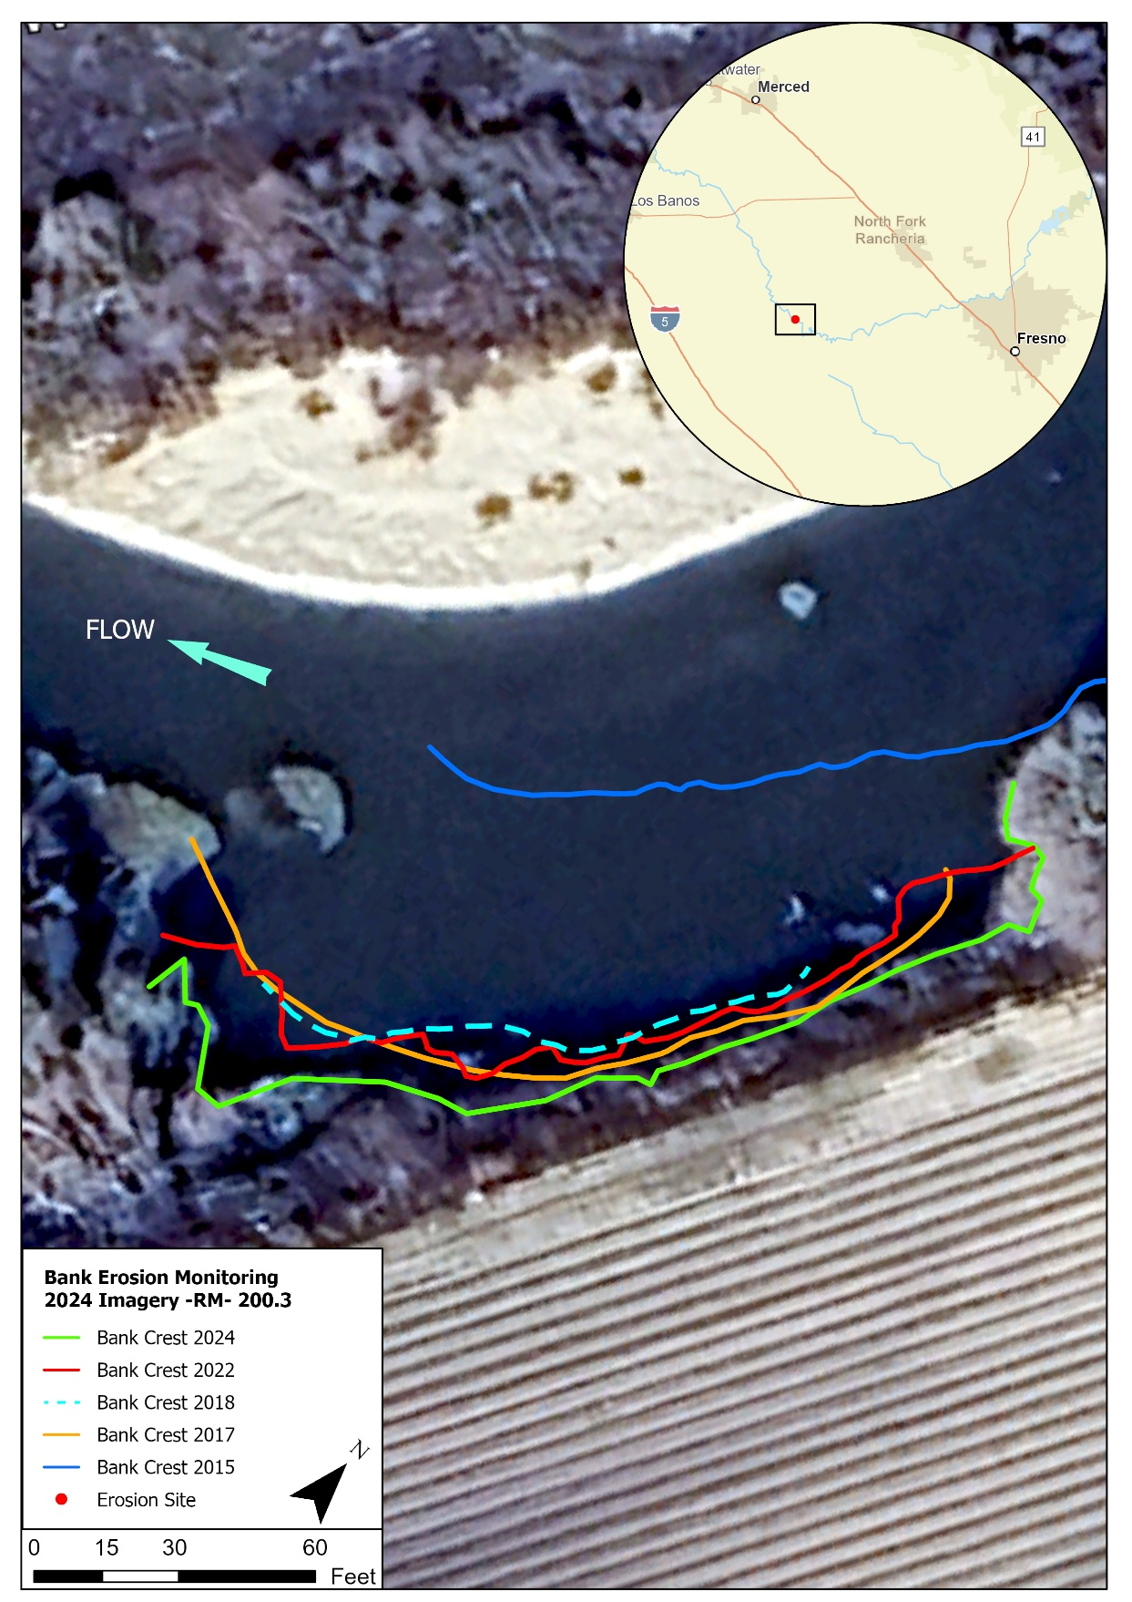

Figure 9 San Joaquin River Reach 3, RM 194.4, Threat Ratio 1.38, Threat Level: High
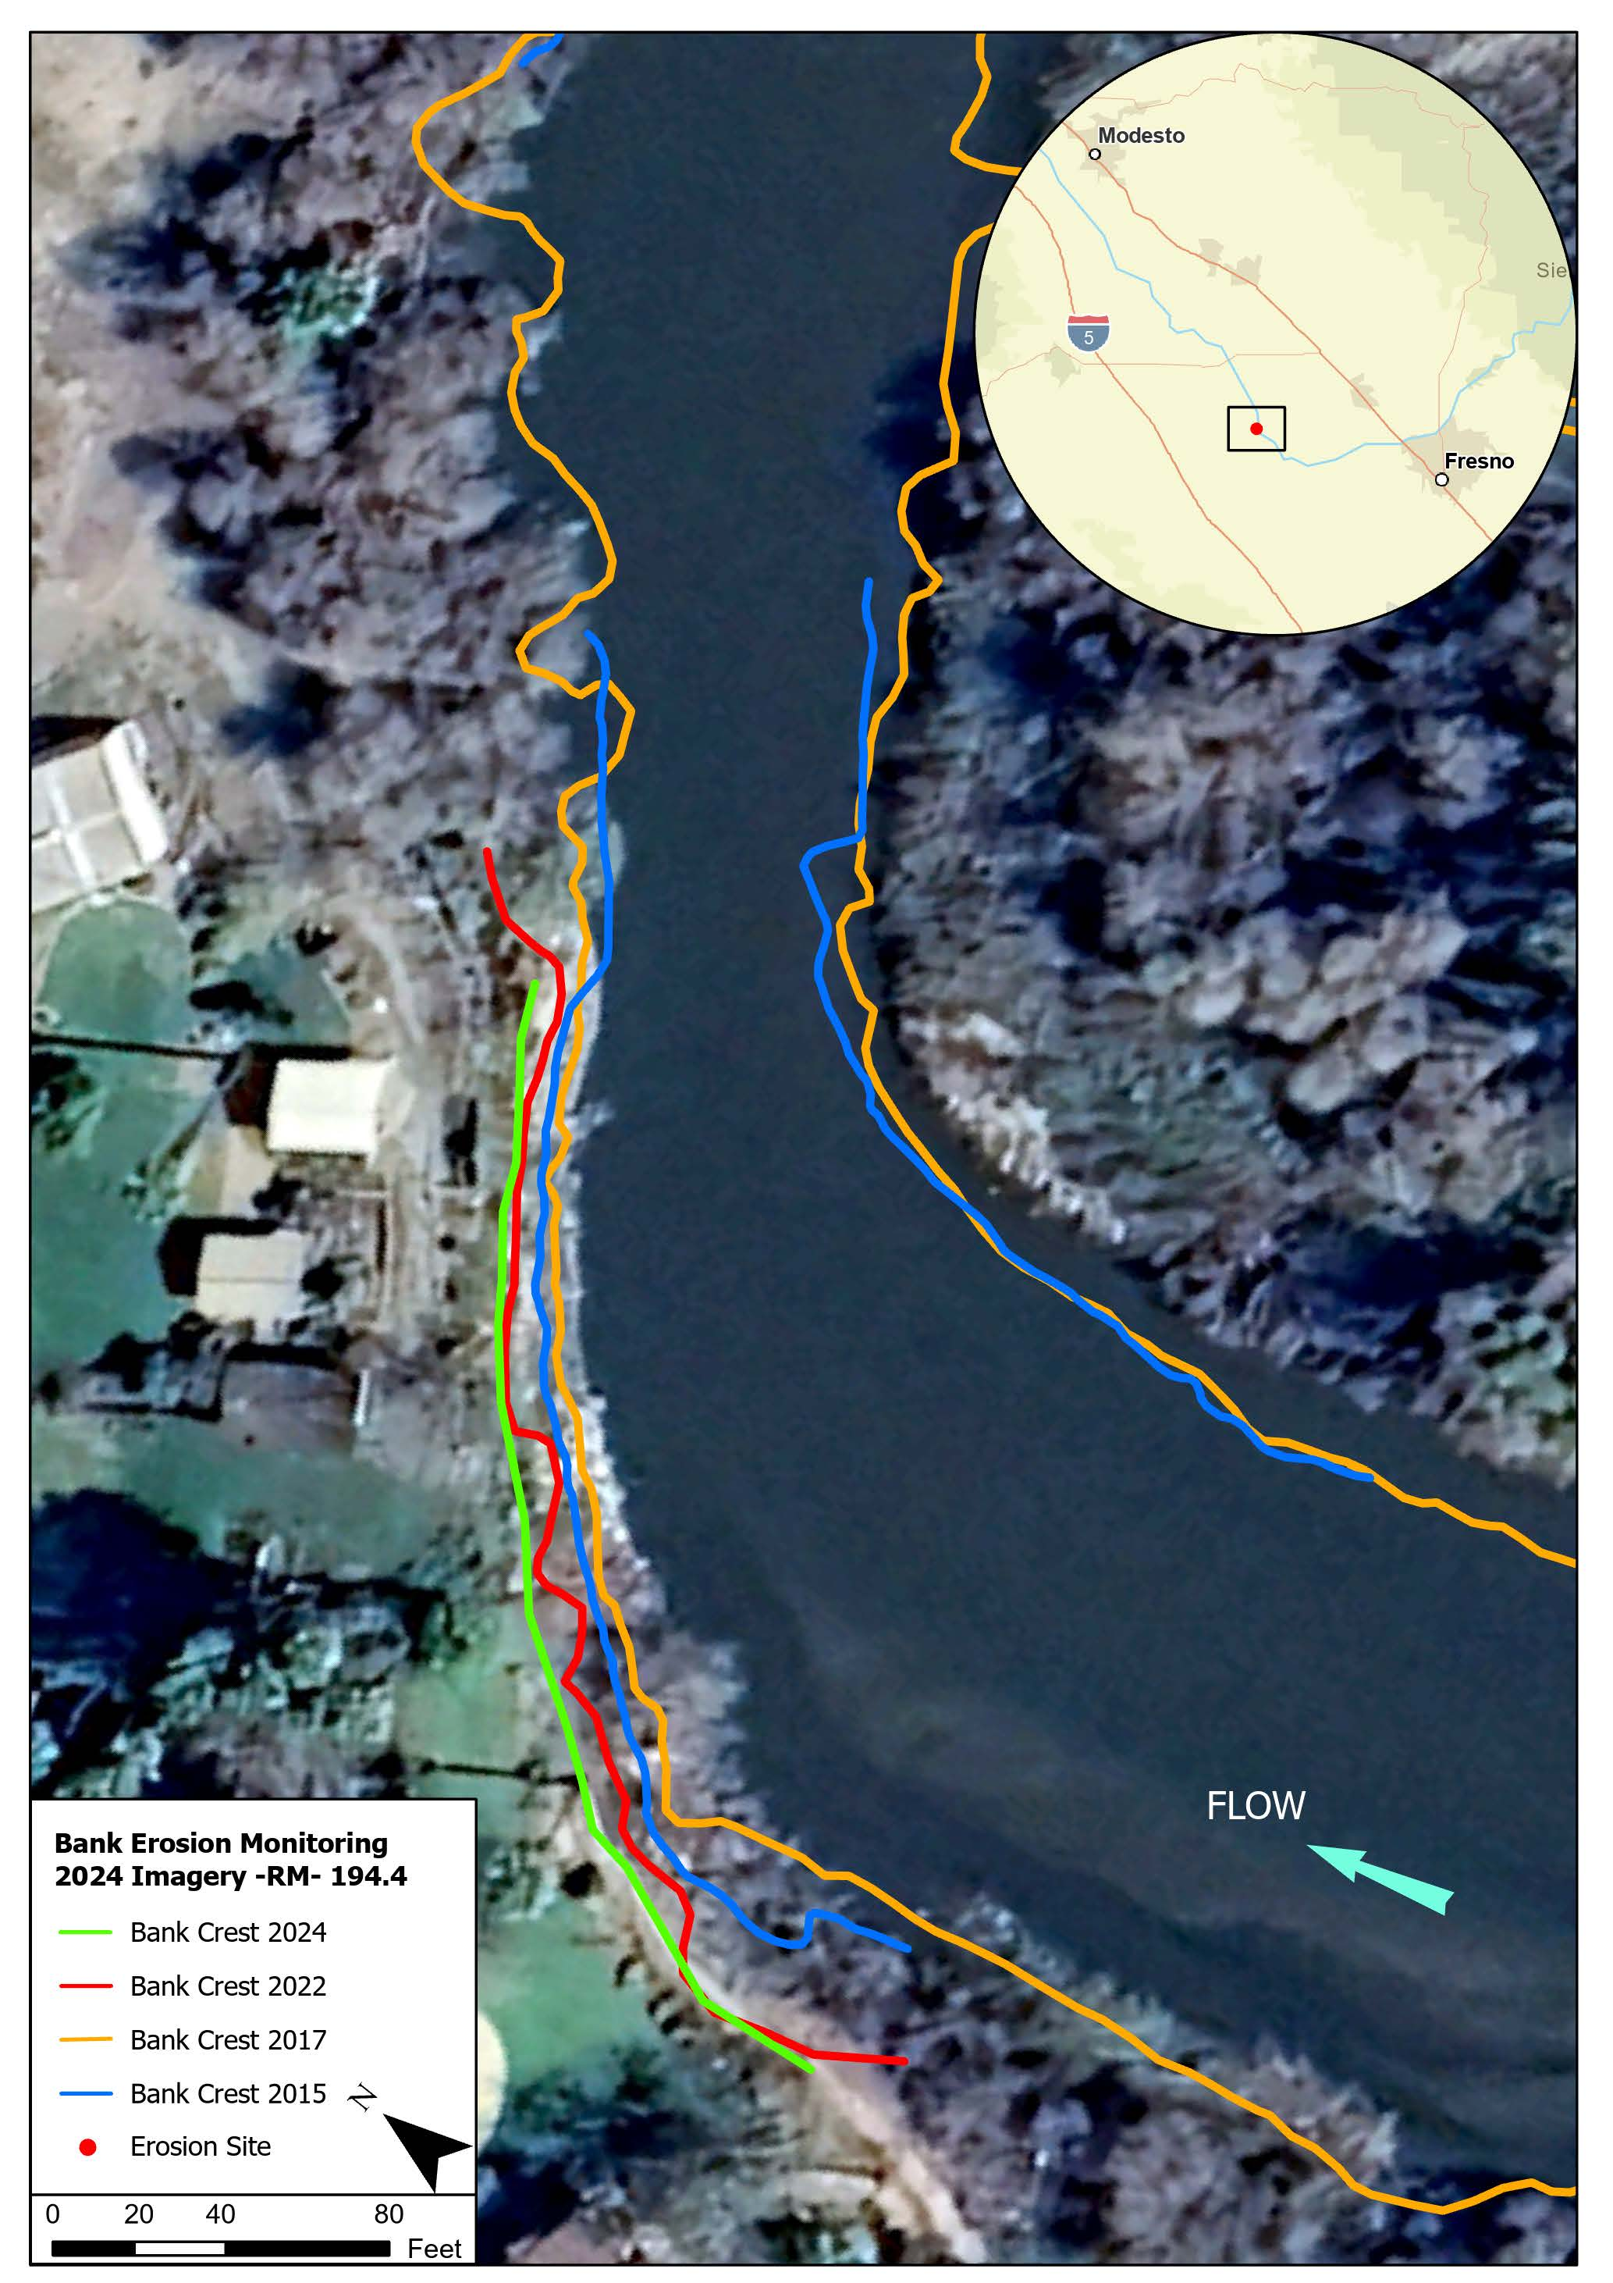

Figure 10 San Joaquin River Reach 5, RM 131.3; Threat Ratio 0.0, Threat Level: High
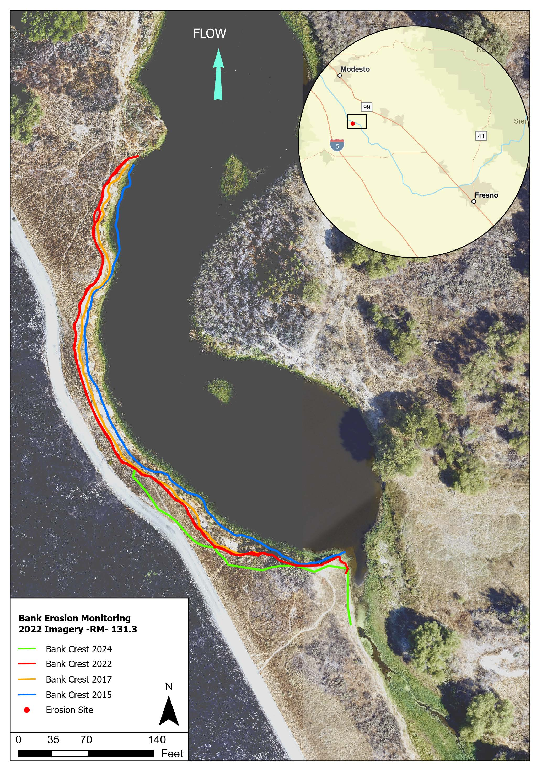

Lower San Joaquin Levee District Flood Threat Sites
During the 2023 flood management releases, as part of their ongoing monitoring efforts for flood control purposes, the LSJLD identified existing and potential flood-threat sites along several reaches including: 2A, 2B, 3, 4A, Middle Eastside Bypass (MESB), and Upper Eastside Bypass (UESB). A number of sites were identified with various issues, including erosion, boils, and seepage. Some of these sites are listed in Table 3 along with the LSJLD descriptions, DWR’s threat classifications from 2017, and updated classification using available imagery from either 2023 or 2024. The table does not include all sites identified by the LSJLD but focuses exclusively on erosion-related threats; other issues such as seepage and boils were not included.
Table 3 Threat Classifications for Levee District Sites
RM | Reach | Levee District Flood Threat Label | DWR 2017 Threat Classification | DWR 2023/2024 Threat Classification
225.4 | 2A | Site 7 Erosion | Low | High
222.5 | 2A | Site 1 Erosion | High | High
220.6 | 2A | Flooding Threat High | High | High
219.8 | 2A | Flooding Threat High | Low | Medium
219.3-left bank/levee | 2A | Flooding Threat High | Low | Unclear¹
219.3-right bank/levee | 2A | Flooding Threat High | Not Determined | Unclear¹
218.5 | 2A | Flooding Threat High | Low | Unclear¹
218.4 | 2A | Flooding Threat High | Not Determined | Unclear¹
217.5-left bank/levee | 2A | Flooding Threat High | Low | Unclear¹
217.5-right bank/levee | 2A | Flooding Threat High | Not Determined | Unclear¹
217 | 2A | Flooding Threat High | Low | Unclear¹
216.2 | 2A | Flooding Threat High | Low | Unclear¹
209.5 | 2B | Flooding Threat High | Low | Low
196.8 | 3 | Flooding Threat High | Low | Low
196.15 | 3 | Flooding Threat High | Low | Low
194.9 (left bank/levee) | 3 | Flooding Threat High | Not Determined | High
194.9 (right bank/levee) | 3 | Flooding Threat High | Low | Low
194.55 | 3 | Flooding Threat High | Low | Low
194.4 | 3 | Flooding Threat High | High | High
193 | 3 | Flooding Threat High | Not Determined | Unclear¹
192.8 | 3 | SJR Private Levee Break | Not Determined | Unclear¹
183.3 | 3 | Flooding Threat High | Low | Low
180.5 | 4A | Flooding Threat High | Low | Low
177.6 | 4A | Flooding Threat High | Low | Unclear¹
168.4 | 4A | Flooding Threat High | Not Determined | Unclear¹
16.3 | MESB | Flooding Threat High | Not Determined | Unclear¹
16.3 | MESB | Site 10, Wave Wash | Not Determined | High
16.2 | MESB | Flooding Threat High | Not Determined | Unclear¹
15 | MESB | Flooding Threat High | Not Determined | Unclear¹
15 | MESB | Site 3 Erosion Site | Low | High
Avenue 18.5 bridge | UESB | Site 6, Bridge Foundation Erosion | Not Determined | High
Washington Road bridge | UESB | Site 11, Bridge Closed | Not Determined | Unclear¹
¹ Flow/inundation, imagery or vegetation makes it difficult to calculate the extent of erosion and classify the threat level.
A total of 32 LSJLD sites were identified by DWR as having potential erosion threats. To validate their significance, the sites were cross-referenced with the results from the previous erosion report conducted in 2021. 19 out of the 32 sites had been previously identified by DWR in the 2021 report, falling under a range of threat classifications between low, medium, and high. Threat ratios and classifications were updated where recent aerial imagery was available in Google Earth between 2023 and 2024 to review changes after the 2023 flood. However, the delineations for several sites were unclear due to inundation extents in the imagery making erosion observations challenging. While half of these sites remain uncertain regarding erosion, a few are apparent erosion sites. Sites from the LSJLD list classified as either medium- or high-threat after the 2023 flood are further described in the following section.

RM 225.4 (Threat Classification - High)
Located in Reach 2A along the right bank, this site is labeled “Site 7, Erosion” by the LSJLD and identified by DWR as a low threat site in 2017. Critical observations were made during a site visit in March 2023 by the LSJLD. The nearest threatened structure is a levee positioned 25 feet away, with an orchard beyond it. Notably, a maximum of 56 feet of lateral erosion along the river-right bank line during the 2023 flood. This erosion encroached into the levee prism. In response, California Governor's Office of Emergency Services (CALOES) with assistance from the adjacent landowner, installed 3,500 tons of rock to stabilize the erosion site. Despite this protective measure, the calculated threat ratio for this site is equal to 0.45 and is a new high threat site that should be monitored to ensure that the rock protection is stable and assess if erosion continues beyond its extent.

RM 222.5 (Threat Classification - High)
Located in Reach 2A along the left bank, this threat site was previously identified and discussed in Section 4.1 High Threat Sites Update (2024).

RM 220.6 (Threat Classification - High)
This threat site is located in Reach 2A along the right bank and was previously identified and discussed in Section 4.1 High Threat Sites Update (2024).

RM 194.9 (left) (Threat Classification - High)
This site is located in Reach 3 at RM 194.9 along the left bank line. The LSJLD labeled this site as a high flooding threat, but it was unclear whether the threat was erosion related. We assumed the threat was a concern to Riverside Park in the town of Firebaugh and assessed erosion around it. This site was not identified by DWR in 2017, but recent observations have shown some erosion after the 2023 flood. Erosion was observed along the left bank near the upstream end of the site, approximately 350 feet from the bridge crossing on 13th Street. Given that the park appears to be situated on the floodplain, we considered the threatened infrastructure to be the park itself and labeled this site as a high threat since erosion is occurring along the park boundaries. Additional information is needed to further assess the threat level and determine whether monitoring should continue for this site.

RM 194.4 (Threat Classification - High)
This site is located in Reach 3 and was previously identified and discussed in Section 4.1 High Threat Sites Update (2024).

RM 16.3 (Threat Classification - High)
Located in the MESB at RM 16.3, this site is labeled "Site 10, Wave Wash" by the LSJLD. It was not identified by DWR in 2017. This site is along a levee improvement project completed by DWR in 2020. On March 28, 2023, the LSJLD reported wave wash damage on the levees to the Flood Operations Center (FOC). By March 30th, California Conservation Corps (CCC) crews responded and began wave wash protection efforts. Flow inundation in recent aerial imagery complicates direct observation of erosion damage. However, data collection and site visits were conducted at this site and erosion was observed along the levee prism classifying this site as a high threat.

RM 15 (Threat Classification - High)
Located in the MESB, this site is labeled “Site 3, Erosion Site” by the LSJLD. It was not identified by DWR in 2017. In January 2023, DWR FOC reported that the levee was failing due to erosion. By April 2023, CALOES had initiated a rock contract to address the issue. Based on 2024 imagery (Google Earth), we observed approximately 23 feet of lateral erosion since 2017 that began eroding into the levee toe and classifying this site as a high threat. Although rock slope protection was added to protect the levee, this site should be monitored to ensure the stability of the protections and assess whether erosion continues beyond its extent.

Avenue 18.5 Bridge (Threat Classification - High)
Located in the UESB, this site is labeled “Site 6, Bridge Foundation Erosion” by the LSJLD. It was not identified by DWR in 2017. During the 2023 flood, erosion was visibly impacting the bridge embankment. Consequently, the bridge was closed after being reported to Madera County Office of Emergency Services (EOS) and the Public Works department in January 2023. The threat level is assumed to be high due to the significant impact on the bridge embankment.

RM 219.8 (Threat Classification - Medium)
Located in Reach 2A, this site is labeled “Flooding Threat High” by the LSJLD. It was previously identified by DWR as a low threat in 2017. The nearest threatened structure is a levee positioned 82 feet away. Lateral erosion was measured to be 13.5 feet between 2015 and 2024, with a minimum distance to the levee measured to be 82 feet. The resulting threat ratio is equal to 6.1 after the 2023 flood, classifying this site as medium threat.

Conclusion and Recommendations
Building on past assessments, this update tries to distinguish erosion patterns between different flow types including Restoration Flows, contract deliveries and flood management releases. This was conducted using aerial imagery before and after flood events in 2019 and 2023 and focuses primarily on the high-threat sites identified in the 2021 bank erosion monitoring report, but also includes a cursory review of threatened sites identified by the LSJLD during the 2023 flood management releases. The LSJLD sites provide insight on the need to monitor additional sites for new erosion and previously identified sites that may have worsening conditions and threat classifications. This 2024 Bank Erosion Monitoring Report marks another step forward in our efforts to understand and monitor erosion within the Restoration Area. By following these recommendations, the Program can collect better data to inform and address any potential erosion threats resulting from Restoration Flows. Continual monitoring will improve the understanding of how Restoration Flows, contract deliveries, and flood management releases effect the erodible perimeter of the river and bypasses. Further monitoring and analysis will be necessary to understand the causal mechanisms of erosion in the Restoration Area and to confirm that Restoration Flows are not causing erosion-related impacts.
Review of the aerial photos indicate that the previously identified high-threat sites have undergone notable changes, with some experiencing worsening conditions. The magnitude of erosion varied per site but generally shows less erosion during Restoration Flows in comparison to significantly higher flood management releases. Specifically, sites at RM 262.20 and 258.50 showed little to no erosion during the Restoration Flow period between 2017 and 2018, and more erosion in comparison following flood management releases in 2019 and 2023. These high-flow events appear to be a significant factor contributing to additional erosion at these sites. Similar trends were observed at RM 222.5, and 220.60. Some sites such as RM 202.60 exhibited consistent erosion trends despite the flow type. Overall, although most of the additional erosion observed could be linked to higher flows during flood management releases, erosion patterns are largely dependent on specific site conditions where hydraulic, geotechnical, and vegetation conditions vary and impacts how erosion changes over time.
Insights from the LSJLD have emphasized the importance of monitoring not only high-threat sites but also medium- and low-threat sites identified in the previous report, and potentially new sites that were not yet identified. The dynamic nature of erosion could lead to worsening threat classifications over time and include new erosion sites, as evidenced by some sites identified by the LSJLD during the 2023 flood management releases. Therefore, it is important to periodically evaluate these sites to detect early signs of high-threat erosion and coordinate with the appropriate entities for preventative measures if necessary.
Based on these observations, the following actions are recommended prior to the next report to further understand how Restoration Flows, contract deliveries, and flood management releases affect erosion sites in the Restoration Area:
- Continued Monitoring of High-Risk Sites: Focused attention should be maintained on high-risk sites identified in this report to protect critical infrastructure and property. Monitoring should be enhanced with advanced methods such as aerial imagery and detailed surveys, which have proven effective in mapping riverbanks and detecting signs of erosion.
- Periodic Evaluation of Medium and Low-Threat Sites: It is essential to occasionally monitor medium and low-threat sites to assess whether they have worsened. This proactive approach will help identify new high-threat sites early and implement timely mitigation measures if necessary.
- Integration of Multiple Monitoring Resources and Techniques: The Program should seek monitoring data from other entities conducting or responsible for erosion monitoring. A combination of monitoring methods, including drone surveillance and detailed field surveys should be employed to gain a comprehensive understanding of erosion trends. These techniques will allow for better correlation of erosion patterns with different flow types.
- Long-Term Monitoring Plan Development: Establishing a long-term monitoring plan is crucial for tracking erosion trends over time. This plan should include regular data collection and analysis to assess the impacts of various flow conditions on bank erosion.
In conclusion, DWR recommends continuing to implement a long-term erosion monitoring plan that would evaluate the causal mechanisms by reach throughout the Restoration Area to reduce or avoid erosion-related Restoration Flow impacts in the Restoration Area. This includes applying the methods outlined above by using remote sensing technology to monitor and detect erosion. When deemed necessary, future studies may include separate investigations of the processes and flow schedules that cause bank erosion.

References
Google Earth. (n.d.). Google Earth [Web application]. Retrieved from Google Earth.
San Joaquin River Restoration Program. 2012. Physical Monitoring and Management Plan. Appendix D. Program Environmental Impact Statement/Report (Draft). 38 pp. [Government Report.] Prepared by U.S. Bureau of Reclamation and California Department of Water Resources. Viewed online at: Microsoft Word - PEISR_AppD_M&MPlan_20110413.docx (usbr.gov).
Accessed: Feb. 12, 2021.
San Joaquin River Restoration Program. 2012. Final Program Environmental Impact Statement/Report. 180 pp. [Government Report.] Prepared by U.S. Bureau of Reclamation and California Department of Water Resources. Viewed online at: 1/Introduction (usbr.gov).
Accessed: Dec. 1, 2020.
San Joaquin River Restoration Program. 2017. Bank Erosion Monitoring Report: Pilot Study Results (draft). California Department of Water Resources, South Central Region Office. 71 pp. [Government Report.]
San Joaquin River Restoration Program. 2021. Bank Erosion Monitoring Report (draft). California Department of Water Resources, South Central Region Office.[Government Report.]
Tetra Tech, Inc. (dba MEI). 2010. Evaluation of Potential Erosion and Stability Impacts on Existing Levees under Proposed Restoration Program (Draft). 48 pp. Prepared for: California Department of Water Resources. [Report.]

